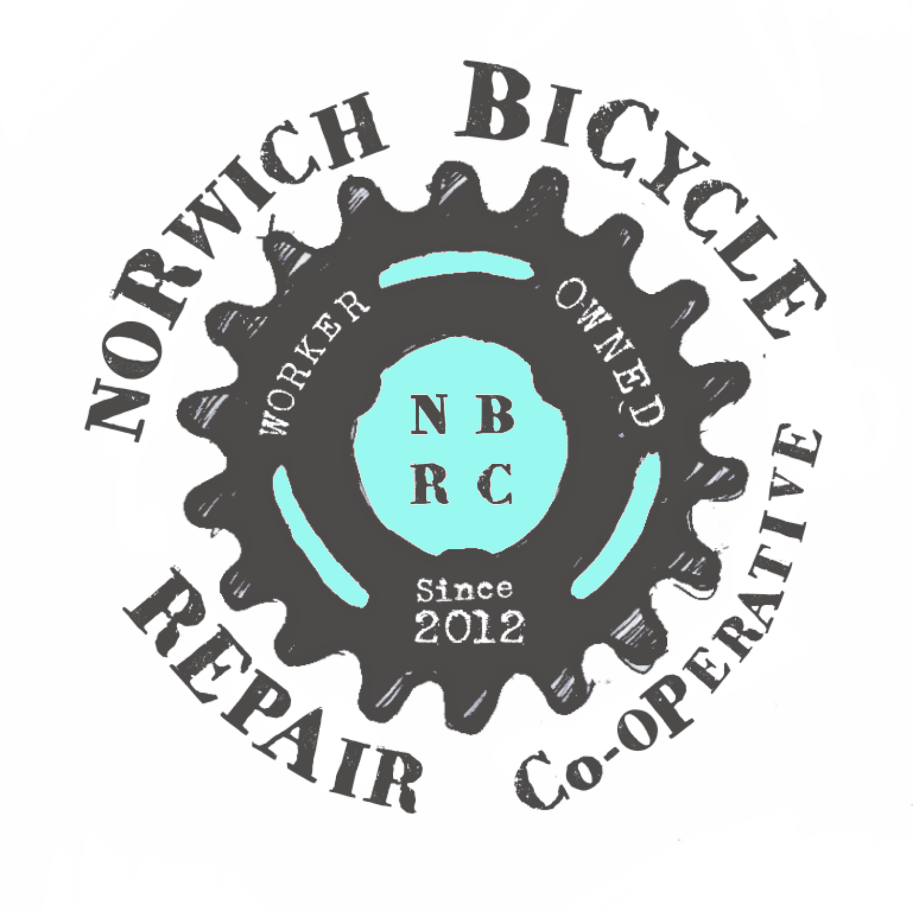
Norwich Bicycle Repair

Co-op

GDPR Statement

Norwich Bicycle Repair Co-operative Ltd. (NBRC) is committed to ensuring the security and protection of the personal information that we process, and to provide a compliant and consistent approach to data protection.

This GDPR Compliance Statement explains our approach to implementing our GDPR compliance program. It describes the implementation of our data protection roles, policies, procedures, controls and measures to ensure ongoing compliance with GDPR.

Our GDPR Principles

NBRC takes the privacy and security of individuals and their personal information very seriously. Our principles for processing personal information are:

- We will process all personal information fairly and lawfully
- We will only process personal information for specified and lawful purposes
- Where practical and necessary, we will keep personal information up to date
- We will not keep personal information for longer than is necessary

Data Subjects Rights under GDPR

At NBRC, an individual can request information about:

- What personal information we hold about an individual
- The categories of personal information we collect from an individual
- The purposes for collecting and processing personal information from an individual
- How long we plan to keep the personal information
- The process to have incomplete or inaccurate personal information corrected or completed
- Where applicable, the process for requesting erasure of the personal information or for restricting the processing of personal information in accordance with data protection laws, as well as to object to any direct marketing from us
- About any automated decision-making that we use

Our GDPR compliance plan

Here's an overview of our steps that we are taking to ensure compliance with GDPR at Norwich Bicycle Repair Co-op:

- We conducted a data mapping inventory and analysis of collected personal information in our systems and records
- We have established procedures to restrict processing of personal information
- We have updated our company’s Data Protection Policy, Data Retention Policy, and Information Security Policy
- We have established Data Processing Agreements with our partners
- We have reviewed all processing activities to identify the legal basis for processing personal information and to ensure that each basis is appropriate for the activity it relates to

Contact us if you have GDPR related questions
If you have any questions about this GDPR Compliance Statement, or our privacy or security practices, please contact us:

- Website: http://www.norwichbicyclerepaircoop.co.uk/
- Email: nbrc@norwichbicyclerepaircoop.co.uk
- Phone: 07903 553 286

